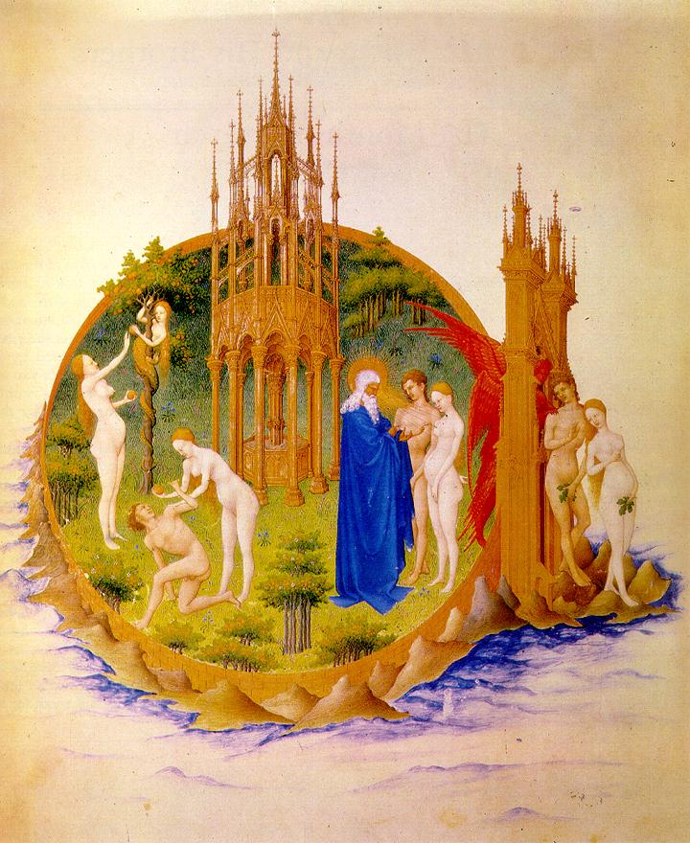
Freedom and Responsibility in Medieval Thought

中世纪思想中的自由与责任

26-27 May 2012
Room 301, Building 7
Peking University Shaoyuan Guest House
(北京大学勺园七号楼301室)
Speakers Include:

Richard Cross (University of Notre Dame)
Tobias Hoffmann (Catholic University of America)
Bonnie Kent (University of California at Irvine)
Simo Knuuttila (University of Helsinki)
John Marenbon (University of Cambridge)
Cyrille Michon (University of Nantes)
Fei Wu (Peking University)
Tianyue Wu (Peking University)
Rong Zhang (Nanjing University)
Dunhua Zhao (Peking University)

A Conference Organized by
Institute of Foreign Philosophy
Department of Philosophy
Center for Classical Studies
Peking University

国 际 学 术 会 议
International Conference

中世纪思想中的自由与责任
Freedom and Responsibility
in Medieval Thought

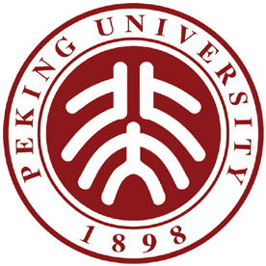

北京大学哲学系
北京大学外国哲学研究所
北京大学西方古典学研究中心
主办

Organised by
Department of Philosophy
Institute of Foreign Philosophy
Centre for Classical Studies
Peking University

会议地点：北京大学勺园7号楼301会议室
Room 301, Building 7, Peking University Shaoyuan Guest House,

时间：2012年5月26日-27日
Conference Dates: 26 – 27 May 2012
会 议 日 程
Agenda
2012年5月25日
25. 05. 2012
19:30 - |  |  | 欢迎晚宴  Welcome Dinner
2012年5月26日
26. 05.2012
开幕式  Opening Speeches: | 主持人：吴天岳（北京大学哲学系）  Chair: Tianyue Wu (Peking University, China)
8:30-8:40 | 发言人  Speaker |  |  | 尚新建，北京大学外国哲学研究所所长  Prof. Xinjian Shang (Director of the Institute of Foreign Philosophy at Peking University)
8:40-8:50 | 发言人  Speaker |  |  | Richard Cross (美国圣母大学哲学系系主任)  Richard Cross (University of Notre Dame, USA)
8:50-9:00 | 照相 |  |  | Taking Photos
第一场：圣经与希腊传统  Session I: The Bible and Greek Tradition |  |  |  |  |  | 主持人：Cyrille Michon (法国南特大学)  Chair: Cyrille Michon (University of Nantes, France)
9:10 - 10:00 |  |  |  |  |  |  | Title: The Biblical Relevance to Virtue Ethics  Speaker: Dunhua Zhao (Peking University, China)
10:00–10:10 |  |  |  |  |  |  | Tea Break
第二场：奥古斯丁  Session II: Augustine |  |  |  |  |  | 主持人：Bonnie Kent (University of California at Irvine, USA)  Chair: Bonnie Kent (University of California at Irvine, USA)
10:10 - 11:00 |  |  |  |  |  |  | Title: Augustine on Freedom and Time  Speaker: Rong Zhang (Nanjing University, China)
11:00 – 11:50 |  |  |  |  |  |  | Title: The Unification of Souls According to St. Augustine  Speaker: Fei Wu (Peking University, China)
12:00–13:30 |  |  |  |  |  |  | 午餐  Lunch
第三场：最初波动  Session III: First Movements |  |  |  |  |  | 主持人：Tobias Hoffmann（美国天主教大学）  Chair: Tobias Hoffmann (Catholic University of America, USA)
13:30 - 14:20 |  |  |  |  |  |  | Title: First Movements in Medieval Theories of Free Will  Speaker: Simo Knuuttila (University of Helsinki, Finland)
14:20-15:10 |  |  |  |  |  |  | Title: Are First Movements Venial Sins? Augustinian Doctrine and Aquinas’s Reinterpretation  Speaker: Tianyue Wu (Peking University, China)
15:10–15:20 |  |  |  |  |  |  | 茶歇  Tea Break
第四场：阿奎那  Session IV: Aquinas |  |  |  |  | 主持人：吴飞（北京大学）  Chair: Fei Wu (Peking University, China)
15:20 - 17:00  17:00 - |  |  |  |  |  |  | Title: Aquinas on Freedom and Alternative Possibilities  Speakers: Tobias Hoffmann (Catholic University  of America, USA)  Cyrille Michon (University of Nantes, France)  晚餐  Dinner
2012年5月27日
27. 05. 2012
第五场：早期中世纪哲学  Session V: Early Medieval Philosophy |  |  |  |  |  |  |  | 主持人：张荣（南京大学）  Chair: Rong Zhang (Nanjing University, China)
08:30 - 09:20 |  |  |  |  |  |  |  |  | Title: Peter Abelard and His Critics on Divine Necessity and Human Freedom  Speaker: John Marenbon (University of Cambridge, UK)
09:20 - 09:30 |  |  |  |  |  |  |  |  | 茶歇  Tea Break
第六场：晚期中世纪哲学  Session VI : Late Medieval Philosophy |  |  |  |  |  |  |  | 主持人：Simo Knuuttila（芬兰赫尔辛基大学）  Chair: Simo Knuuttila (University of Helsinki, Finland)
09:30 - 10:20 |  |  |  |  |  |  |  |  | Title: Peter Olivi on Created Freedom  Speaker: Bonnie Kent (University of California at Irvine, USA)
10:20 - 11:10 |  |  |  |  |  |  |  |  | Title: Natural Law, Moral Constructivism, and Duns Scotus’s Metaethics: The Centrality of Aesthetic Explanation  Speaker: Richard Cross (University of Notre Dame, USA)
会议总结  Closing Session  11:10–11:20  11:20-11:30 |  |  |  |  |  |  |  | 发言人：John Marenbon（英国剑桥大学）  Speaker: John Marenbon (University of Cambridge, UK)  发言人：赵敦华（北京大学）  Speaker: Dunhua Zhao (Peking University, China)
11:30 - |  |  |  |  |  |  |  |  | 告别宴会  Banquet

